**EPNS Workspace Setup document**

**Source code Repo** - <https://github.aig.net/commercial-it-common/uw-epns-1738>

**Branch -** Cloud-Release-1.0.0-1021

**Steps to build WAR:**

**Option 1**: (Without IDE)

1. Download the zip file on clicking Clone or download button from the Git repo –

https://github.aig.net/commercial-it-common/uw-epns-1738/tree/Cloud-Release-1.0.0-1021

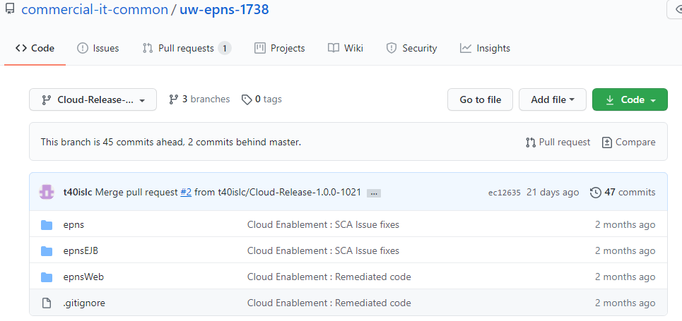

1. Unzip the file
2. Open CMD prompt in windows and navigate to the root folder (…\<unzip-path>\uw-epns-1738\epnsWeb) (Also make sure the presence of gradlew.bat in it)
3. Execute gradle command to clean and build.
   1. **gradlew.bat clean build 🡨** command to execute

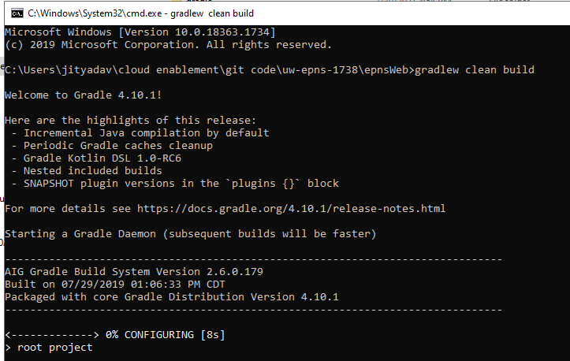

1. Once the build is successful, **target** folder would be created. WAR would be created in \target\archives folder.

**Option 2: (Eclipse)**

1. Download and install latest version of Eclipse IDE.
2. Download the source code (Zip file) from git repo.
3. Create a workspace folder in Window Explorer and unzip the source code.
4. Open Eclipse
5. Configure OpenJdk 11

* Extract openjdk zip file into your local drive.
* Goto Window -> Preferences -> Java -> Installed JREs and click Add.

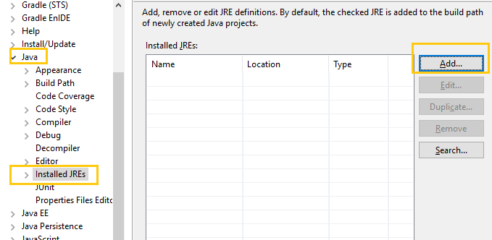

* Select ‘Standard VM’ and click next.
* At ‘JRE home’, browse and locate the JDK extracted at Step 1. Click Finish

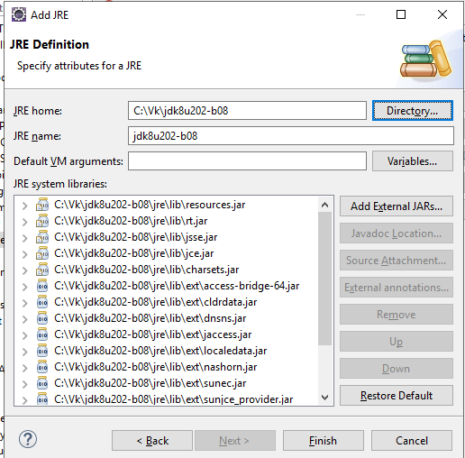

* Make sure the configured JRE is selected and click on Apply & Close

1. Install Gradle plugin if it’s not already available.
2. Navigate to Windows 🡪Show View and add the below tabs into the console.

Gradle Task and Gradle Executions

1. Import the Gradle project via the below path
   1. Import 🡪 Gradle 🡪 Existing Gradle project
2. Follow the import console window with default options and click Finish.
3. Check if the project is visible in Gradle Tasks tab.
4. Expand **Build** folder in the Gradle Tasks tab in the console
   1. Right click **Clean** Task and select Run Gradle tasks
   2. Right click **Build** Task and select Run Gradle tasks
5. Once the build is successful, **target** folder would be created. war would be created in \target\archives folder.
6. Deployment to TomEE(for EPNS service)
   1. **Installation**: Install and configure TomEE 8.0
   2. *Add the below configurations* ***in* $tomEE_installation_dir/bin/*setEnv.bat***

**CONFIG_SERVER_URL=https://springcloudconfignonprod.apps.nprd-pcf.aig.net  
APPLICATION_NAME=uw-epns-1738  
ENVIRONMENT_NAME=dev  
ENCRYPT_KEY=nonprodencryptkey**

* 1. **WAR copy**: Navigate to $tomEE_installation_dir\apps and place the WAR
  2. **Start Server**: Navigate to $tomcat_installation_dir\bin in CMD prompt. Execute catalina run command
     1. Catalina run
* **Validate the application using below url on local : -**

localhost:8080/epns/html/epnslogin.html